1. **Write a C program to search a number using Binary Search method.**

**PROGRAM:**

**#include <stdio.h>**

**int binarySearch(int arr[], int left, int right, int target) {**

**while (left <= right) {**

**int mid = left + (right - left) / 2;**

**if (arr[mid] == target)**

**return mid;**

**if (arr[mid] < target)**

**left = mid + 1;**

**else**

**right = mid - 1;**

**}**

**return -1;**

**}**

**int main() {**

**int arr[] = {2, 4, 6, 8, 10, 12, 14, 16, 18, 20};**

**int n = sizeof(arr) / sizeof(arr[0]);**

**int target = 12;**

**int result = binarySearch(arr, 0, n - 1, target);**

**if (result == -1)**

**printf("Element not found\n");**

**else**

**printf("Element found at index %d\n", result);**

**return 0;**

**}**

**INPUT:**

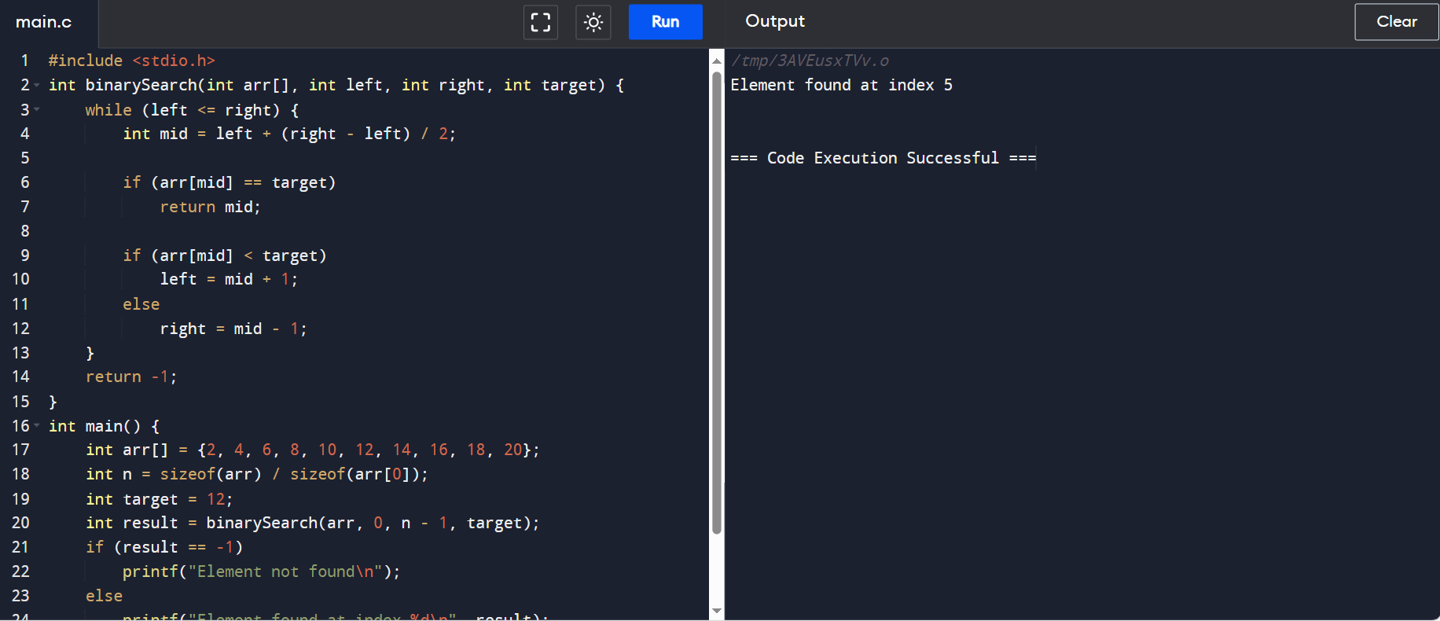

**OUTPUT:**

